The applicant shall complete all sections, sign and submit to Port Otago MARINE
Duty Pilot for Approval AT LEAST 24 HOURS Prior to work.
□ Applicant Checklist has been reviewed with the applicant prior to the commencement of work

NOTE: All dives within 200m of a Port Otago Limited facility including navigation aids, wharf facilities and the like require a Dive Permit

SECTION 1: GENERAL
Applicant Company / Agent :____________________ Location / Berth / Vessel________________________

Phone: Email / Fax: __________________________________

Diving Company:_____________________________ Phone:___________________

Diver / Supervisor in Charge of Dive:_____________________________

Phone: Email / Fax: __________________________________

Approval Valid From:__________(Hrs) Date:____________ To: _____________(Hrs) Date:_____________

Description Of Work_______________________________________________________________________
Type of Dive: □ Commercial □ Scientific □ Other
Equipment / Personnel:

NOTE: For Nav Aid location attach a marked up extract of the relevant marine chart to this Approval.
For other facilities indicate location on diagram D1 or D2 below:
Diagram D1 - Port Chalmers Wharfs
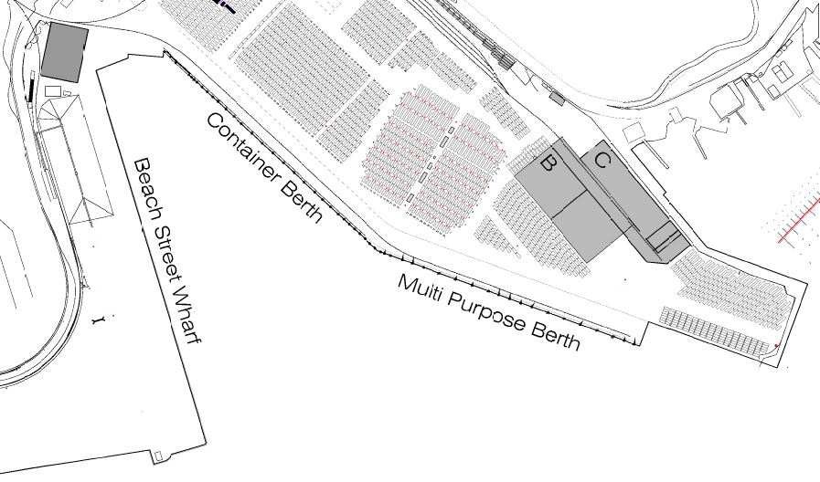

SECTION 2: PERMIT PRECAUTIONS CHECKLIST | Y | N | N/A
Does the work involve:
Excavation, cutting, drilling, penetrating ground by more than 100mm, or drilling into walls? | □ | □ | □
Work with potential to generate heat or spark, (e.g. welding, cutting, grinding, abrasive blasting etc.) result in fire associated with equipment, vessels, or structures in vicinity incl fire associated with other operations e.g. bunkering? | □ | □ | □
Abrasive blasting? | □ | □ | □
Any space not designed for normal work, where rescue may be difficult e.g. VOID SPACES, Internal Vessel Structures, within tanks? | □ | □ | □
High Voltage (HV) incl entry to any signed HV space or cabinet. 240V electricity which cannot be isolated. Sewer or sewage systems, gas or high pressure water? | □ | □ | □
Work on Port Otago Limited operational areas requiring decreased speed limits or use of safety barriers or has the potential to impact traffic flow? | □ | □ | □
Handling dangerous goods (DG) incl DG transported onto or off Port Otago Limited land transported onto or loaded onto or off vessels, or in transit on vessels in Port? | □ | □ | □
Removal of native vegetation, work in or near a previously undisturbed area or within a Protected Marine Environments. | □ | □ | □

SECTION 3: PERMIT CONDITIONS | Y | N | N/A
Completed Port Otago Limited Contractor Induction for all Divers and Supervisors. | □ | □ | □
Barricades and warning signage are to be in place at all times. | □ | □ | □
Hoses, electrical leads and equipment have been tested / tagged. | □ | □ | □
All Diving operations will be carried out in accordance AS/NZS 2299.1:2007 and any other relevant Government Laws, Regulations or Bylaws. | □ | □ | □
All dive equipment is serviceable and in current survey / certification. | □ | □ | □
Dive Supervisor will monitor VHF CH14 & 16 for vessel traffic around dive site. | □ | □ | □
Dive Supervisor will notify Port Otago Limited Harbour Control (VHF CH 14)  on 03 472 9882 of Commencement and Completion of each dive. | □ | □ | □
All divers, standby divers and supervisors will have current medicals. | □ | □ | □
Copies of divers licenses to be available on inspection | □ | □ | □
Display Alpha Flag so it is visible to passing craft | □ | □ | □
Add isolation/tag out procedures of vessel to main engine | □ | □ | □

SECTION 4: REQUIRED PERMIT DOCUMENTATION | Y | N | N/A
JHA / JSA has been prepared for the works, if not, provide explanation: | □ | □ | □
Dive plan. | □ | □ | □
Emergency Evacuation Procedure / Safety Plan. | □ | □ | □

EXCLUSION: Dives requiring decompression are NOT APPROVED

SECTION 5: DIVer’s names & leVEl of qualification held

Diagram D2 - Dunedin Wharfs + Ravensbourne
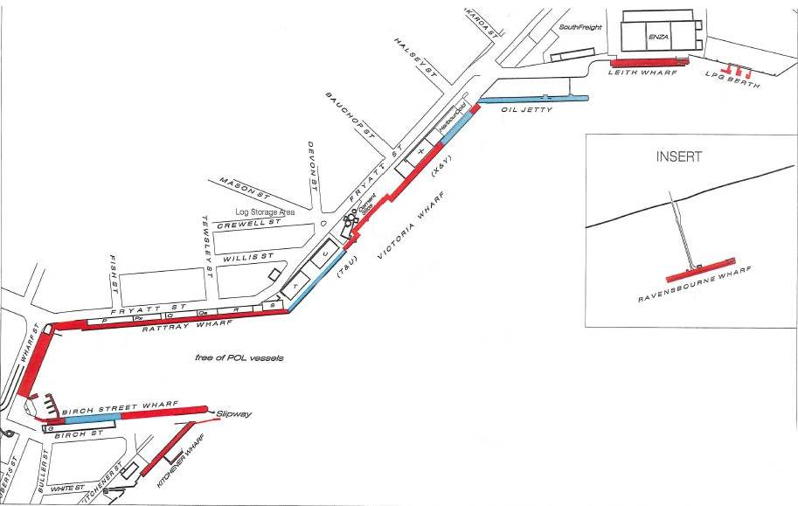

SECTION 6: PERMIT APPROVAL & ACCEPTANCE
If the Applicant is the Company which will carry out the work, by applying for this approval it makes the following warranties, undertakings and acknowledgements:
- The Applicant warrants that it understands the nature of the work and the risks associated with it has sufficient competence to carry out the work and accepts responsibility (including occupational health and safety responsibility) for the work.
- The Applicant undertakes to notify Port Otago Limited as soon as possible after it identifies any issue which would prevent the work from being carried out safely, and to liaise with Port Otago Limited to allow the work to be carried out safely.
- The Applicant warrants that, where it has particular expertise or technical knowledge with respect to the work permitted by the Permit.
If the Applicant is not the Company which will carry out the work, by applying for this Permit it makes the following warranties, undertakings and acknowledgements:
- The Applicant warrants that it understands the nature of the work and risks associated with it.
- The Applicant undertakes to take whatever steps are required to ensure that the Company which will carry out the work understands the nature of the work and risks associated with it.
- The Applicant warrants that the Company which will carry out the work has sufficient competence to carry out the work and accepts responsibility (including occupational health and safety responsibility for the work.
- The Applicant undertakes to take whatever steps are required to ensure the Company which will carry out the work notifies Port Otago Limited as soon as possible after it identifies any issue which would prevent the work from being carried out safely and liaises with Port Otago Limited to allow the work to be carried out safely.
Applicant’s Authorised Representative:

______________________________________ ____________________________________________ ________________________
(Name) (Signature + Title) (Date)
Approval Authoriser:

______________________________________ ____________________________________________ ________________________
(Name) (Signature) (Date)

SECTION 7: PERMIT CLOSE OFF
The work has been completed and all persons who had a role in carrying out the work, materials and equipment have been withdrawn. The work area has been made safe and all operational activities can resume
Authorised Representative of Applicant Signed OR Company in Charge of Works Signed

______________________________________ ____________________________________________ _______________________
(Name) (Signature + Title) (Date)
Permit Authoriser:

______________________________________ ____________________________________________ _______________________
(Name) (Signature + Title) (Date)

